63 Algoma Street North – Suite 120
Dr. Trevor Deleo
Thunder Bay, ON, P7A 4Z6
Phone: (807) 344-4077 Fax: (807) 344-4090

PATIENT INTAKE FORM - CHIROPRACTIC
Patient Name:_________________________________________ Birth Date (D/M/Y):______ /_____ /________ Age: _____ Assigned Gender: □Female □Male Email:____________________________________________________
Address: ______________________________ City: _______________________Postal code: _____________
Preferred Phone #: ___________________________ OHIP #: ______________________________ Version Code: _______
Occupation: ________________________________ Family Doctor: __________________________________
How did you hear about our clinic? __________________________ Referred By: ________________________
Please mark where the pain is located.

ADDRESSING THE ISSUE THAT BROUGHT YOU TO OUR OFFICE
- What is your major symptom/
problem? __________________________________
- When did your symptoms begin?_____________________________________________
- Have you had this problem before? □Yes □No
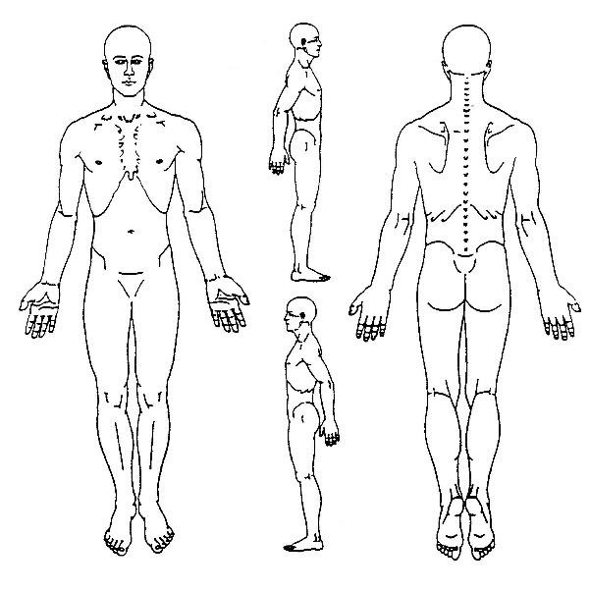
- Is the problem there □constant □comes & goes □with use □at rest?
- Is the problem getting □worse □no change □better?
- What makes it worse?______________________________________
- What makes it better?______________________________________
- How does it feel? □Burning □Sharp □Shooting □Dull □Stiff □Aching □Tingling □Throbbing
□Swelling □ Other:___________________________________________________________
- How would you rate the sensitivity of your pain (0=no pain, 10=severe pain)? _____________
- Does it interfere with your: □Work □Sleep □Daily Routine □Recreation?
- What test have you had for this condition? □Spinal Exam □X – ray □MRI □CT Scan
- Have you received any treatment for this condition? □Orthopedic □Physiotherapy □Massage Therapy □Acupuncture □Surgery (Date D/M/Y: _______________) Other: _______________________________
Medi
cations

Allergies

Supplem
entations

Patient Health Questionnaire
Please check ( ) if any of the following apply to you. Knowledge of these conditions may influence the type of treatment you receive.
 | YES | NO |  | YES | NO |  | YES | NO |  | YES | NO
AIDS/HIV |  |  | Diabetes |  |  | Liver Disease |  |  | Rheumatoid Arthritis
Alcoholism |  |  | Emphysema |  |  | Measles |  |  | Rheumatic Fever
Allergy Shots |  |  | Epilepsy Fractures |  |  | Migraine headaches |  |  | Scarlet Fever
Anemia |  |  | Glaucoma |  |  | Mononucleosis |  |  | Sexually Transmitted Disease
Anorexia |  |  | Goiter |  |  | Multiple Sclerosis |  |  | Stroke
Appendicitis Arthritis |  |  | Gonorrhea |  |  | Mumps |  |  | Suicide Attempt
Asthma |  |  | Gout |  |  | Osteoporosis |  |  | Thyroid Problems
Bleeding Disorders |  |  | Heart Disease |  |  | Pacemaker |  |  | Tonsillitis
Breast Lump |  |  | Hepatitis |  |  | Parkinson’s Disease |  |  | Tuberculosis
Bronchitis |  |  | Hernia |  |  | Pinched Nerve |  |  | Tumors, Growths
Bulimia |  |  | Herniated Disc |  |  | Pneumonia |  |  | Typhoid Fever
Cancer |  |  | Herpes |  |  | Polio |  |  | Ulcers
Cataracts |  |  | High Blood Pressure |  |  | Prostate Problem |  |  | Vaginal Infections
Chemical Dependency |  |  | High Cholesterol |  |  | Prosthesis |  |  | Whooping Cough
Chicken Pox |  |  | Kidney Disease |  |  | Psychiatric care |  |  | Other:

Are you pregnant?: □No □Yes How many weeks? ________
HAVE YOU EVER:
Had an accident (car,fall,sport,other)? □No □Yes, please describe:_____________________________________
Had an operation? □No □Yes, please describe:___________________________________________________
Had a fracture? □ No □Yes, please describe:_____________________________________________________
Been hospitalized? □No □Yes, please describe:________________________________________________
FAMILY HISTORY: Have your grandparents, parents or siblings ever been diagnosed with any of the following?
□  □  □  □  □  □ | High Blood Pressure  Heart Stroke  Stroke  Diabetes (Type I or Type II)  Thyroid/ Hormone Problems  Breathing or lung problem | □  □  □  □  □  □ | Rheumatoid Arthritis  Osteoarthritis  Neurological problems  Cancer  Kidney Disease Other (specifiy):

I certify that all the above personal health information, on page one and two, is complete and accurate to the best of my knowledge. I agree to notify this doctor immediately whenever I have changes in my health condition in the future.
Informed Consent to Examine: By signing I am allowing Dr. Trevor Deleo to conduct a thorough neuro/orthopeadic examination with the intent to diagnose musculoskeletal disorders.
Print Patient Name:_____________________________________________________
Patient or Guardian Signature:______________________________ Date (D/M/Y) ______ /______ /___________

